1. **Literature review**

* Research on drivers of rents is quite limited, both internationally and in NZ
* Most of the research has been focused on drivers of house prices.
* Rents tend to enter the equation as given or projected fixed annual increase.
* However, as the rental has similar products, it's possible to replicate previous studies on house prices using rent prices as dependent variable.

Potential determinants – expected signs, mechanism/channel, estimation method, past results

* 1. Income/wages

* 1. Relative supply and demand
     1. People per dwelling
     2. Separate people and dwelling
     3. Vacancy rate

* 1. Lagged rent inflation
  2. Mortgage rate
  3. House price
  4. Inflation excluding rents

* 1. Unemployment rate

1. Regression results

2.1. Data

2.1. Lag selection

2.2. Baseline results

|  |  |  |  |  |
| --- | --- | --- | --- | --- |
|  | **Rent inflation (nominal, flow)** | **Rent inflation (nominal, flow)** | **Rent inflation (nominal, stock)** | **Rent inflation (real, flow)** |
| *Predictors* | *Estimates* | *Estimates* | *Estimates* | *Estimates* |
| Rent inflation (lagged) | -0.17  (0.12) | -0.19 * (0.11) | 0.51 *** (0.12) | -0.28 ** (0.14) |
| Wage | 0.48 *** (0.11) | 0.55 *** (0.09) | 0.08 *** (0.03) | 0.59 *** (0.11) |
| Wage (lagged) | 0.28 *** (0.10) | 0.27 *** (0.10) | 0.07 *** (0.02) | 0.24 ** (0.12) |
| People per dwelling | -0.47  (0.78) |  |  |  |
| People per dwelling (lagged) | 1.89 ** (0.85) | 1.74 *** (0.55) | 0.31 ** (0.14) | 3.28 *** (0.68) |
| Floating mortgage rate | 0.02  (0.02) |  |  |  |
| Floating mortgage rate (lagged) | 0.03  (0.02) | 0.03  (0.02) | 0.01 ** (0.00) | 0.01  (0.02) |
| Inflation excluding rents | -0.11  (0.20) |  |  |  |
| Inflation excluding rents (lagged) | 0.19  (0.20) | 0.15  (0.17) | -0.00  (0.04) | -0.27  (0.27) |
| Unemployment rate | 0.46  (0.30) |  |  |  |
| Unemployment rate (lagged) | -0.49 * (0.29) | -0.07  (0.10) | -0.07 ** (0.03) | -0.06  (0.13) |
| House price | 0.00  (0.06) |  |  |  |
| House price (lagged) | 0.10  (0.07) | 0.09 * (0.04) | 0.01  (0.01) | 0.13 ** (0.05) |
| Observations | 73 | 73 | 61 | 73 |
| R2 / R2 adjusted | 0.492 / 0.380 | 0.457 / 0.390 | 0.595 / 0.533 | 0.450 / 0.381 |
| Frequency | Quarterly | Quarterly | Quarterly | Quarterly |
| *\* p<0.1   ** p<0.05   *** p<0.01*  *All variables entered the equation as quarterly change, except for unemployment rate.* | | | | |

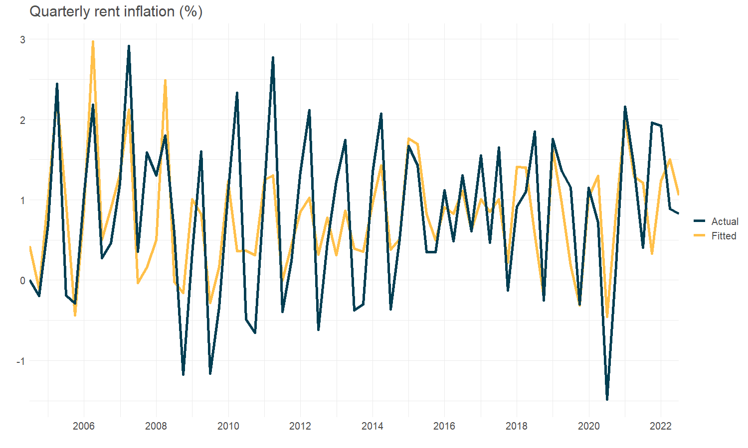

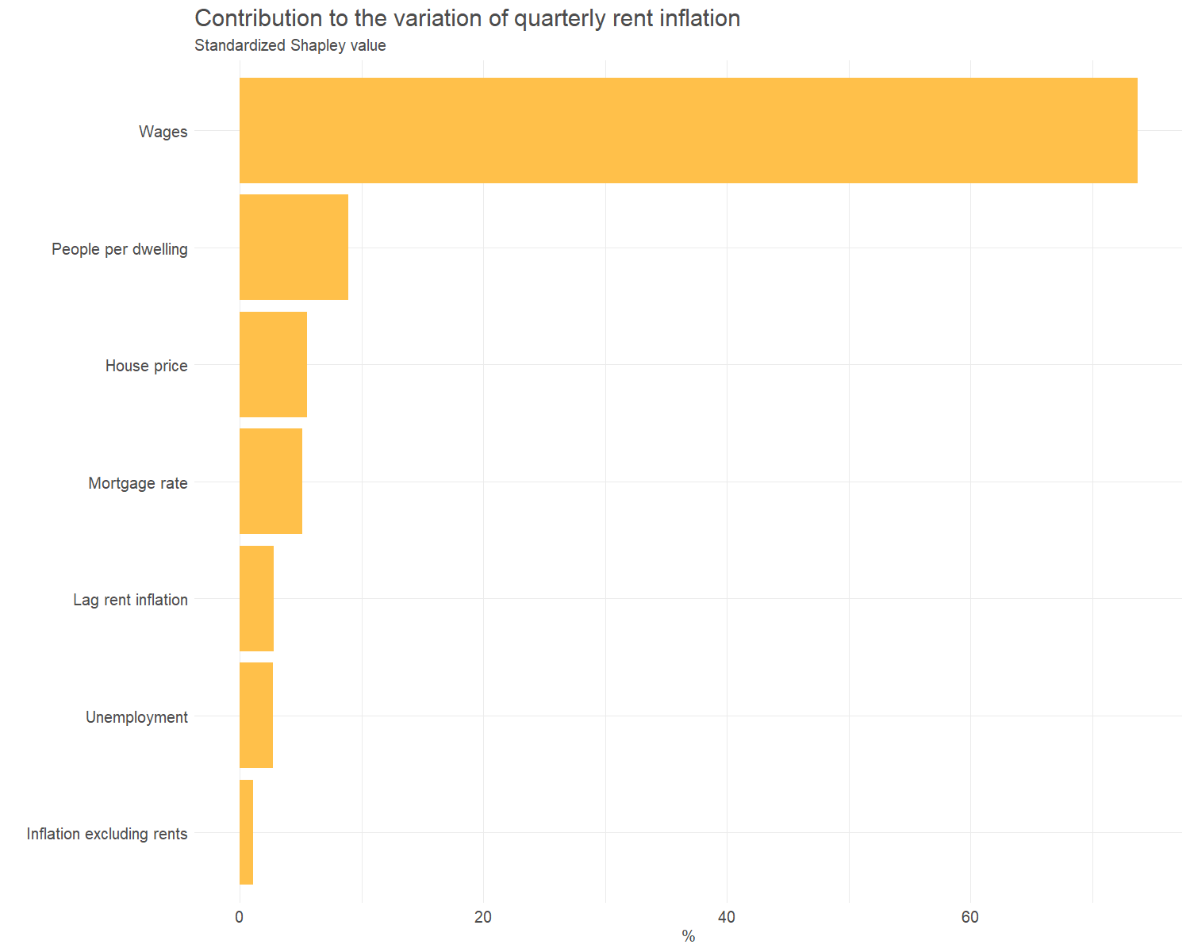

2.3. Alternative specification

|  |  |  |  |  |
| --- | --- | --- | --- | --- |
|  | **Rent inflation (nominal, flow)** | **Rent inflation (nominal, flow)** | **Rent inflation (nominal, flow)** | **Rent inflation (nominal, flow)** |
| *Predictors* | *Estimates* | *Estimates* | *Estimates* | *Estimates* |
| People per dwelling (lagged) | 1.74 *** (0.55) |  |  |  |
| Adults per dwelling (lagged) |  | 1.54 *** (0.47) |  |  |
| Population growth (lagged) |  |  | 1.56 *** (0.57) |  |
| Dwellings growth (lagged) |  |  | -3.46 ** (1.61) |  |
| Change in vacant time (days, lagged) |  |  |  | -0.09 *** (0.02) |
| Observations | 73 | 73 | 73 | 73 |
| R2 / R2 adjusted | 0.457 / 0.390 | 0.461 / 0.394 | 0.468 / 0.392 | 0.497 / 0.435 |
| *\* p<0.1   ** p<0.05   *** p<0.01* | | | | |

2.4. Annual frequency with appropriate lags

|  |  |
| --- | --- |
|  | **Annual rent inflation (nominal, flow)** |
| *Predictors* | *Estimates* |
| Rent inflation (lagged) | -0.38 *** (0.14) |
| Wage | **0.44 *** (0.12)** |
| Wage (lagged) | **0.58 *** (0.14)** |
| People per dwelling (lagged) | **1.26 *** (0.35)** |
| Floating mortgage rate (lagged) | 0.03 ** (0.01) |
| Inflation excluding rents (lagged) | -0.07  (0.15) |
| Unemployment rate (lagged) | 0.14  (0.16) |
| House price (lagged) | 0.09 *** (0.03) |
| Observations | 67 |
| R2 / R2 adjusted | 0.565 / 0.505 |
| *\* p<0.1   ** p<0.05   *** p<0.01* | |